

**Introduction to Database System**

**Project Phase 02**

Submitted by:

|  |  |
| --- | --- |
| Section: O2 | |
| **Muhammad Sinnan Hamid** | **L1F21BSSE0036** |
| **Hafiz Faizan Ahmed** | **L1F21BSSE0030** |

Submitted to:

**MR. Khyzar Khiyat**

Submission date:

**January 15, 2023**

Table of Contents

ERD Design: 3

1. Chen’s Notation: 3

2. Crow’s Foot Notation: 4

Relation Mapping on ERD: 5

1. Relation Mapping: 5

# ERD Design:

## Chen’s Notation:

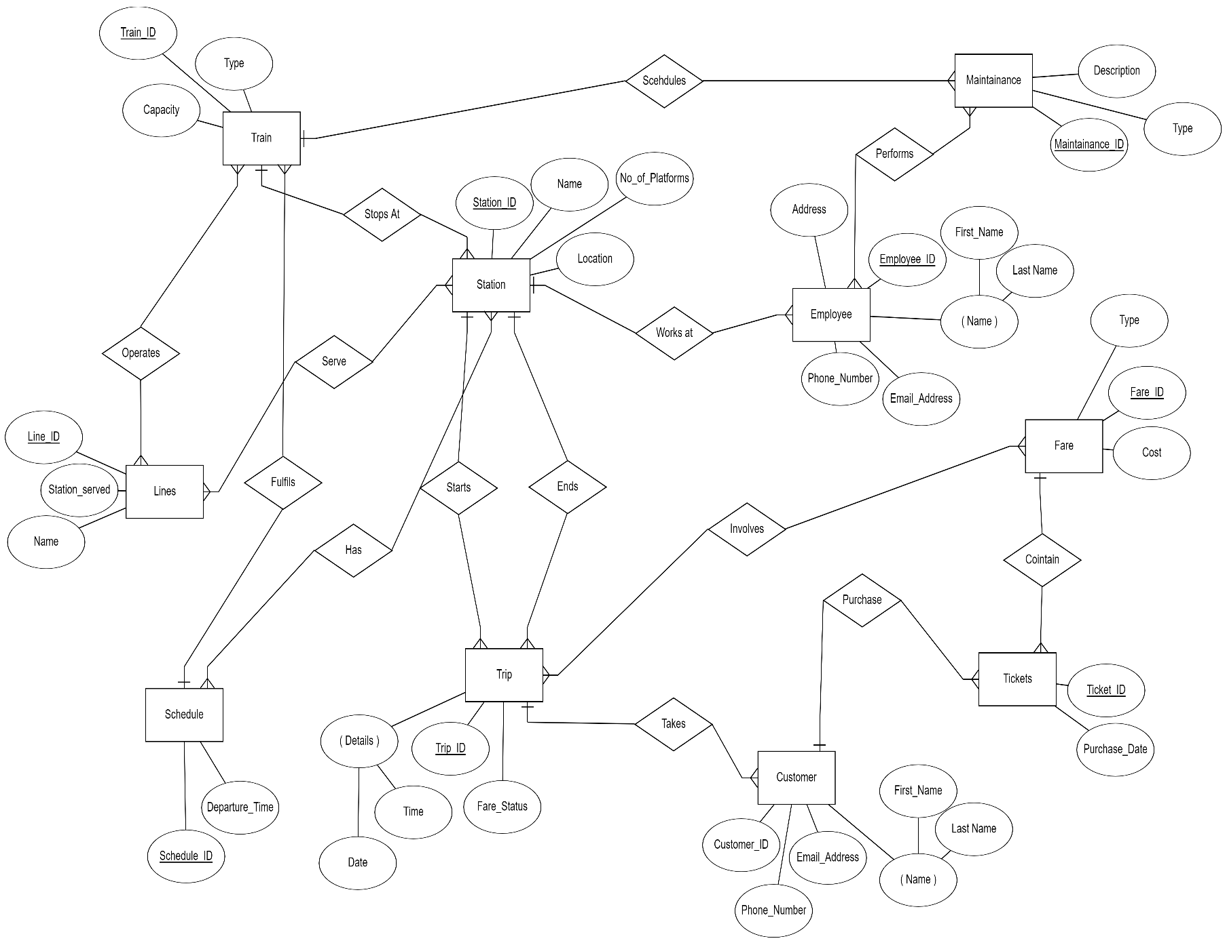

## Crow’s Foot Notation:

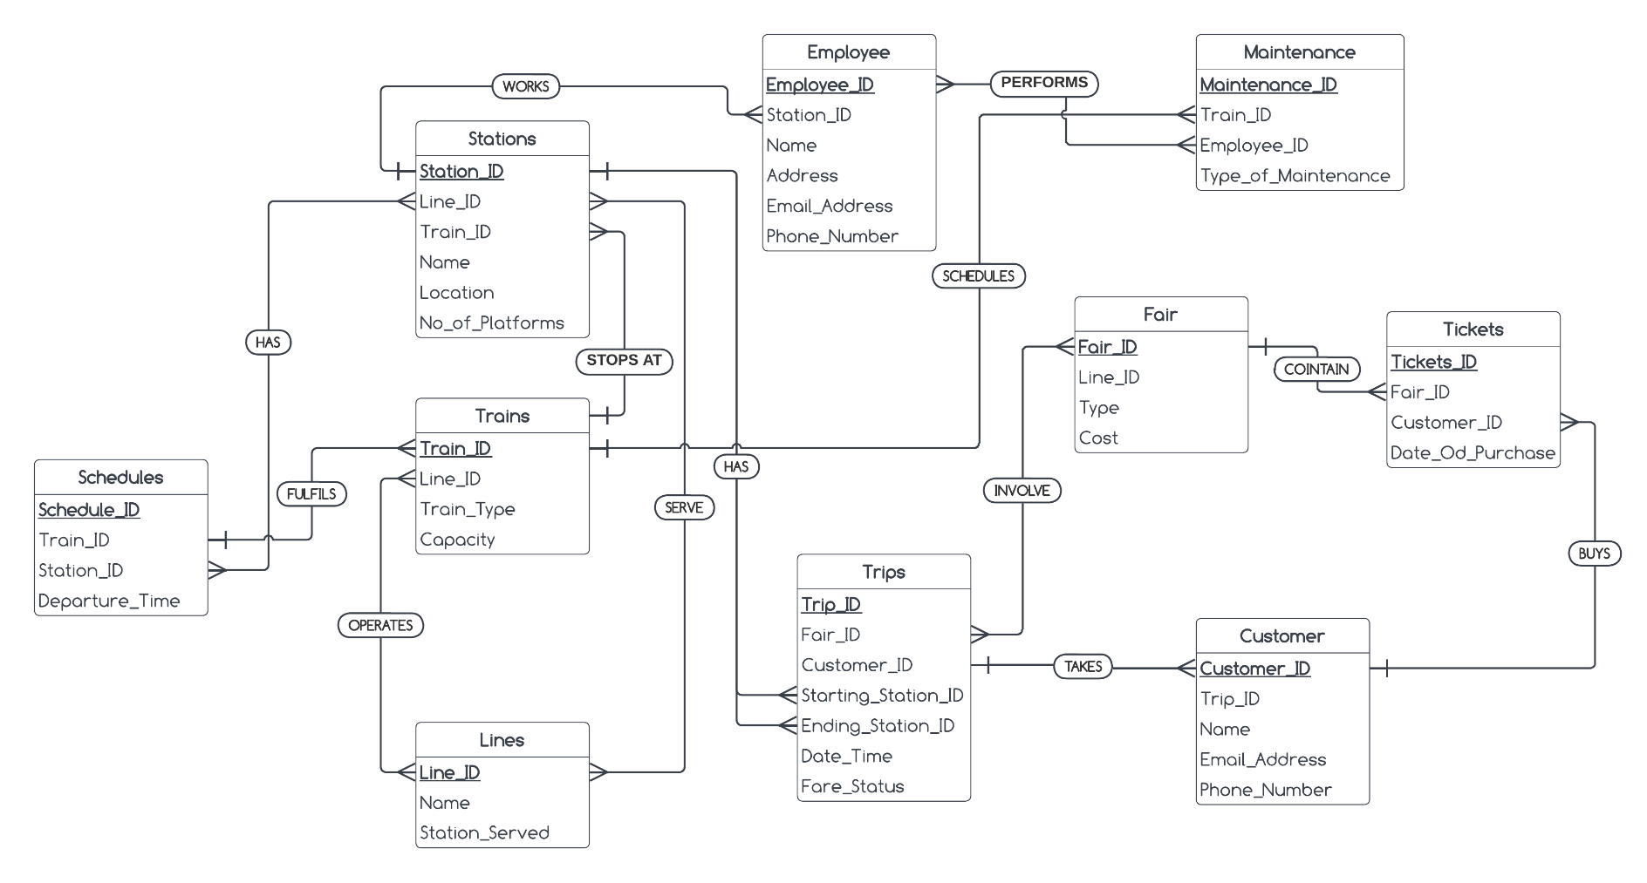

# Relation Mapping on ERD:

## Relation Mapping:

